 |  |  |  |  | YOH-SHINN INDUSTRIAL CO.,LTD. |  |  |  |  |  |  |  |  |  | Client：  T E L ：  F A X ：  D a t e:
NO. 217, Nongchang Rd., Wang Da Industrial Park, Daliao Township, Kaohsiung County 83160, Taiwan  TEL: 886-7-788-6988  FAX: 886-7-788-9399  e-mail：yoh.shinn@msa.hinet.net |  |  |  |  | Lifting screw Conveyors  Quotation
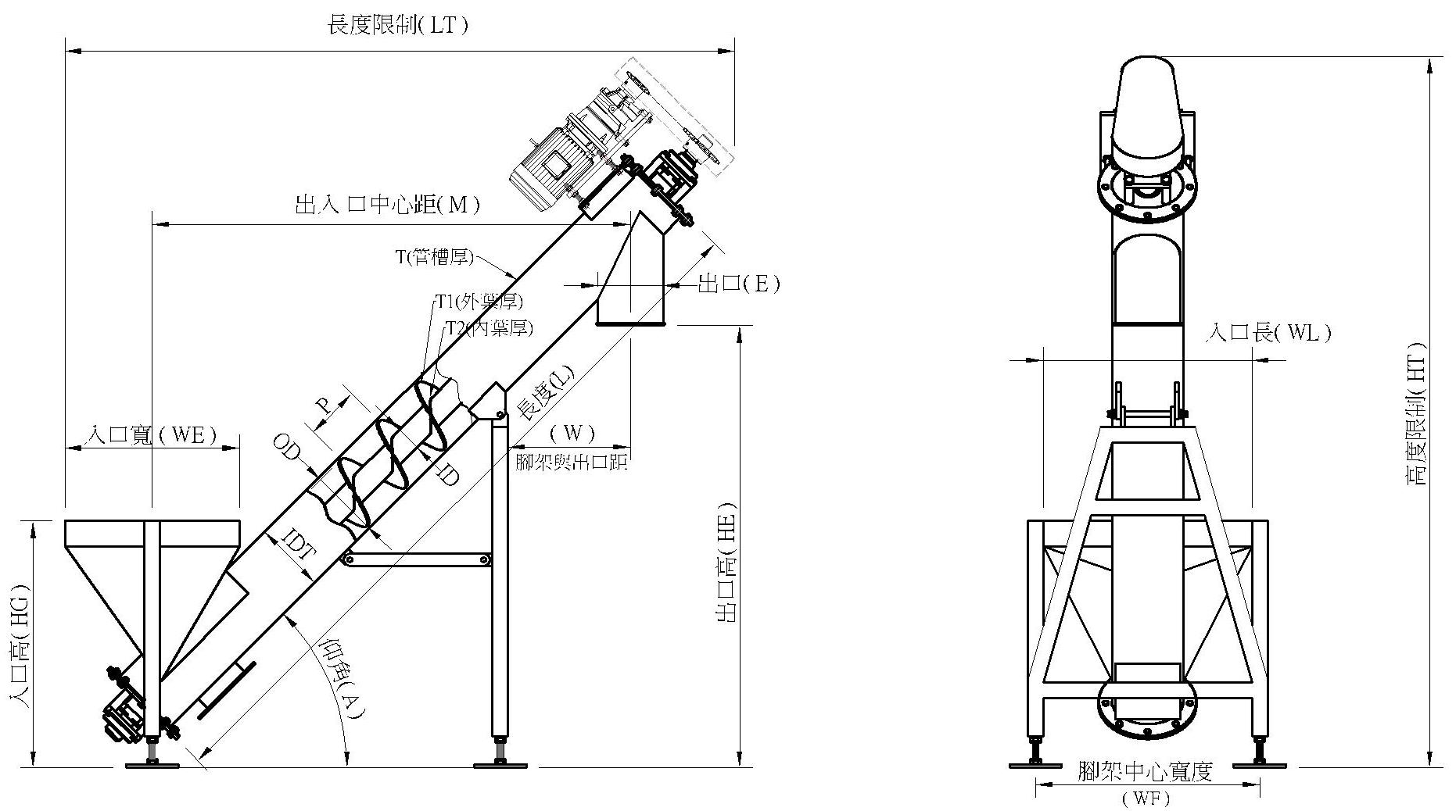
LT | HT |  | WF |  |  | Inlet spouts  HG |  | Outlet  spouts  HE |  | inlet and outlet distance(M) |  |  | A | Inlet spouts WE |  |  | Inlet spouts WL |  | Foot.Shelf outlet spouts  W
Screw Shafts  Material | OD |  | ID |  |  | Tubular Shaft(T) |  | Pitch |  | Thickness1 |  | Thickness2 |  | HP |  |  | RPM |  | R/L
Tubular Trough  Material |  | Pipe IDT |  | Tubular Trough  T |  |  | L |  | ψ E |  | Q'ty |  |  |  |  | UnitPrice |  | Sub-total
Note：
1.Delivery terms:
2.Delivery time:

