 |  |  |  |  |  | YOH-SHINN INDUSTRIAL CO.,LTD. |  |  |  |  |  |  |  |  |  | Client：  T E L ：  F A X ：  D a t e:
NO. 217, Nongchang Rd., Wang Da Industrial Park, Daliao Township, Kaohsiung County 83160, Taiwan  TEL: 886-7-788-6988  FAX: 886-7-788-9399  e-mail：yoh.shinn@msa.hinet.net |  |  |  |  |  | Tubular Trough Screw Conveyors  Quotation
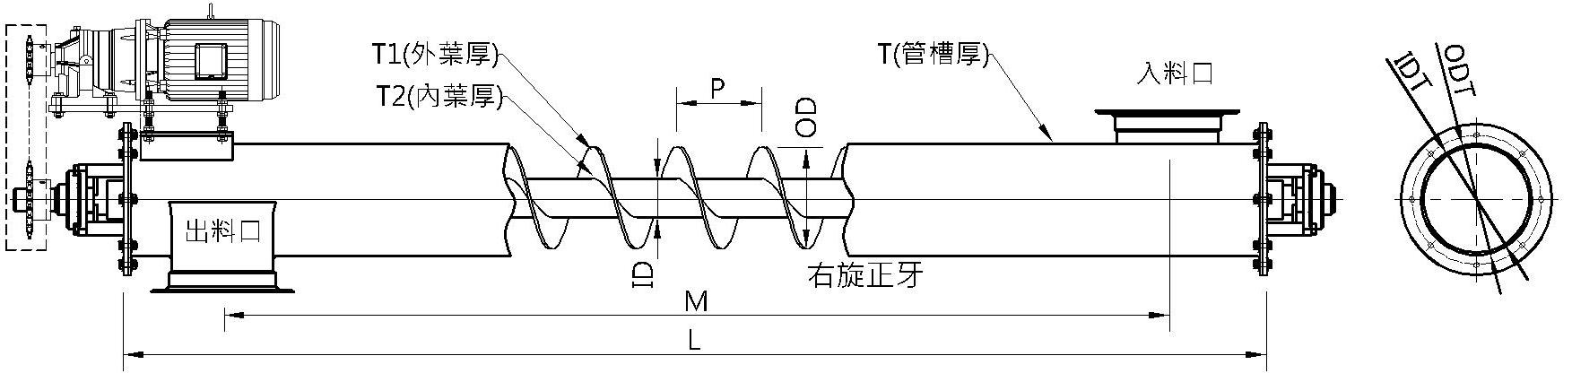
Screw Shafts  Material | OD |  | ID |  | Pipe.shaft Thickness |  |  | Pitch |  | Thickness1 |  | Thickness2 |  | HP | RPM |  |  | R/L | inlet and outlet distance
Tubular Trough  Material |  | Tubular Trough  ODT |  | Tubular Trough  IDT |  |  | Tubular Trough  T |  | L |  | inlet spouts size |  | outlet spouts size |  | Q'ty |  | UnitPrice |  | Sub-total
Note：
1.Delivery terms:
2.Delivery time:

