 |  |  |  |  | YOH-SHINN INDUSTRIAL CO.,LTD. |  |  |  |  |  |  |  |  |  |  | Client：  T E L ：  F A X ：  D a t e:
NO. 217, Nongchang Rd., Wang Da Industrial Park, Daliao Township, Kaohsiung County 83160, Taiwan  TEL: 886-7-788-6988  FAX: 886-7-788-9399  e-mail：yoh.shinn@msa.hinet.net |  |  |  |  | Trough Screw Conveyors Quotation
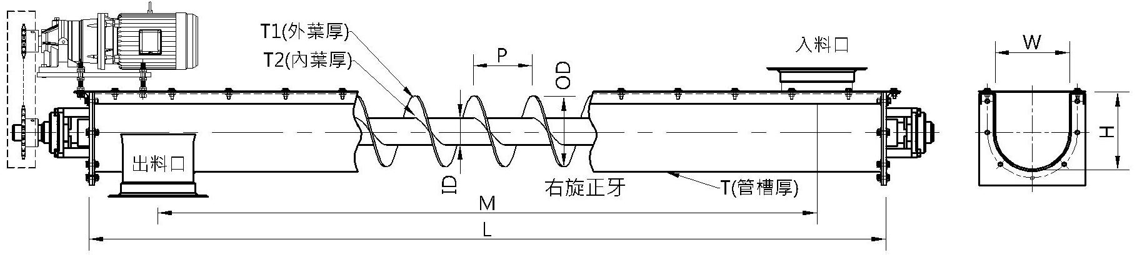
Screw Shafts  Material | Pipe.shaft Thickness |  | Flighting  Material |  |  | OD |  | ID |  | Pitch | T1 |  | T2 |  | HP |  | RPM | R/L |  | inlet and outlet distance
Trough Material | Trough W | Trough H |  | L |  |  | Trough  Thickness |  | inlet spouts size |  |  | outlet spouts size |  | Q'ty |  |  | UnitPrice |  | Sub-total
Note：
1.Delivery terms:
2.Delivery time:

