 |  |  |  | NO. 217, Nongchang Rd., Wang DaIndustrial Park, Daliao Township, Kaohsiung County 83160, Taiwan  TEL: 886-7-788-6988  FAX: 886-7-788-9399  e-mail：yoh.shinn@msa.hinet.net |  |  |  |  |  |  |  |  | YOH-SHINN INDUSTRIAL CO.,LTD.  Screw Shafts  Quotation |  |  |  |  |  |  |  |  |  |  | Client：  T E L ：  F A X ：  D a t e:
 | 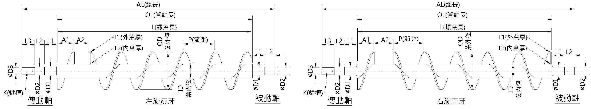
Item |  | Flighting  Material |  |  | Pipe  Material |  |  | Pipe Thickness |  |  | AL |  |  | OL |  | L |  | A1+A2 | Pitch | OD | ID |  | Thickness1 |  | Thickness2 | K | L/R
1
2
Drive/Passive  Shaft |  |  | L1 |  |  | L2 | L3 |  | øD1 | øD2 |  | øD3 |  |  | Q'ty |  | UnitPrice |  | Sub-total |  |  | Note:  1.Delivery terms:  2.Delivery time:
Drive Shaft
Passive Shaft
Drive Shaft
Passive Shaft

